

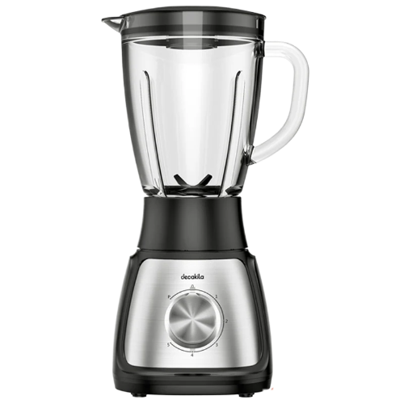

# Decakila KEJB002W Stand Blender

• With glass jug

• 5 speeds control with pulse

• Plastic body with stainless steel decoration

• Anti-slip feet design